A MAJOR-PROJECT REPORT

ON

***“POLICY_MANAGEMENT_SYSTEM”***

Submitted to

JAYPEE UNIVERSITY OF INFORMATION TECHNOLOGY

BY

AYUSHI DOGRA 151411

UNDER THE GUIDANCE OF PROF.**Mr. Abhinandan**

SCHOOL OF COMPUTER ENGINEERING

KALINGA INSTITUTE OF INDUSTRIAL TECHNOLOGY

BHUBANESWAR, ODISHA - 751024

2018-2019

|  |  |  |  |  |  |  |
| --- | --- | --- | --- | --- | --- | --- |
| |  | | --- | | School of Electronics Engineering | | **KALINGA INSTITUTE OF INDUSTRIAL TECHNOLOGY**  (Deemed to be University)  BHUBANESWAR | |  | | APRIL 2019 | | | |
|  | | |
|  | | |
|  | | |
|  | | |
|  | | |
|  | | | |
|  | | | |
| **CERTIFICATE**  This is to certify that the project report entitled **“DESIGN OF ON_ROAD_ASSISTANCE_APPLICATION”**   |  |  | | --- | --- | | **KINGSHUK SEN**  **RITIKA RAJ**  **DEBANGANA CHAKRABORTY** | **1514024**  **1508128**  **1304160** |   in partial fulfilment of the requirements for the award of the **Degree of Bachelor of Technology** in **Electronics department and Electrical department** is a bonafide record of the work carried out under my(our) guidance and supervision at School of Electronics Engineering, KIIT (Deemed to be University). | | | |
| Signature of Supervisor 1  Prof. Arindam Deb  School of Electronics Engineering  KIIT (Deemed to be University) | Signature of Supervisor 2  XXXXXXXX  School of Electronics Engineering  KIIT (Deemed to be University) |

|  |  |
| --- | --- |
| **The Project was evaluated by us on _____________** | |
|  | |
| EXAMINER 1 | EXAMINER 2 |
| EXAMINER 3 | EXAMINER 4 |

ACKNOWLEDGEMENTS

We feel immense pleasure and feel privileged in expressing our deepest and most sincere gratitude to our supervisor **Professor Aarti G Agarkhed**, for her excellent guidance throughout our project work. Her kindness, dedication, hard work and attention to detail have been a great inspiration to us. Our heartfelt thanks to you mam for the unlimited support and patience shown to us. We would particularly like to thank her for all her help in patiently and carefully correcting all our manuscripts. We acknowledge the support received from Cognizant company, Pune.We are also very thankful to **Professor Ghanashyam Rout**B.tech project coordinator (Electronics department), Associate Dean Professor **Dr. AmlanDatta** and **Professor Dr. Arun Kumar Ray**, Dean (School Of Electronics) for their support and suggestions duringour course of the project work in the final year of our undergraduate course.

**RITIKA RAJ(1508128)**

**KINGSHUK SEN (1514024)**

**DEBANGANA CHAKRABORTY (1304160)**

ABSTRACT

**Cognizant** is an American multinational corporation that provides IT services, including digital, technology, consulting, and operations services. It is headquartered in Teaneck, New Jersey,United States of America. Cognizant is included in the NASDAQ-100 and the S&P 500 indices. It is also one of the fastest growing Fortune 500 companies. It was founded as an in-house technology unit of DUN & BRADSTREEIN in 1994, and started serving external clients in 1996.

Cognizant had a period of fast growth during the 2000s, becoming a Fortune 500 company in 2011. In 2015, the FORTUNE Magazine named it as the world's fourth most admired IT Services company. In 2017, Cognizant was named in Fortune’s Future 50 list.

Cognizant provides information technology, information security, consulting, ITO and BPO services. These include business & technology consulting, system integration, application development & maintenance, IT infrastructure services, analytics, business intelligence data , warehousing, customer relationship management, supply chain management, engineering & manufacturing solutions, enterprise resource planning, research and development, outsourcing, and testing solutions.

Cognizant has three key practice areas that span its business — Digital Business, Digital Operations, and Digital Systems & Technology.

**Chapter 1**

Introduction

1. **Purpose of this Project**

This Project is aimed at:

• This Project is about the admin and user login in which they would manage and access policies as required.

• This project is about Policy_Management_System where the user/admin end would login to buy, delete and edit policies as per the access rights.

•The admin would enter valid credentials in login page to enter the admin home page and buy, remove , add and search policies.

•Similarly theuser would enter valid credentials in login page to enter the user home page and buy, remove and search policies.

The purpose of this document is to systematically capture requirements for the project and the system to be developed. The document also captures the Functional requirements and serves as an input for the scope of project.

1.1 Objectives

Below are the objectives that shall be fulfilled post the execution of this project:

**Admin**

• Access to admin home page

• User registration & credential authentication

• Add new policies

• Edit Policies

• View existing policies

• Search policies

**User**

**•** User credential authentication

• Access to user home page

• View purchased policies and policies selected and yet to be purchased in the cart

• Buy and view policies

• Search policies

• Remove policies

• Policy Payment

1.2 Intended Audience

• Interns/Project Team

• Mentors and SME’s

**1.1.0 Business Case**

Through proven experience from successful organizations of all sizes, a strong program of policy and procedure management is much more than a necessary evil to have in place in case something goes wrong. Individual policy and procedure documents are the critical framework upon which an organization’s compliance effectiveness and operational success are built. An organization’s policies provide the basic rules, direction and definitions that not only protect a company, but also provide formulas for profitability and productivity. If an organization’s policies and critical procedures are not managed properly, time is wasted, money is lost and risk exposure is elevated.

The solution developed will address the objective in a holistic manner and will have all the features and functionalities which shall let the portal allow a user to keep a record of his policies and buy new policies and admin to add new policies alongwith other features such as edit and search.

**1.1.1 Technologies Recommended**

|  |  |
| --- | --- |
| Front End | HTML5, CSS |
| Middleware | Servlet , JSP , Spring MVC |
| Backend | Oracle/SQL Server |

**1.1.2 Hardware and Software Requirements**

|  |  |  |
| --- | --- | --- |
| Technology | Hardware | Software |
| Java | Desktop PC with 8GB RAM | 1. Eclipse IDE for Java EE Developers  2. Tomcat 9  3. MySQL Workbench /  Oracle 11g express version |

**1.1.3Product Scope**

This product is a powerful web aggregation engine is a core enabling technology of Cognizant solutions and is a fundamental tool for improving the management of policies. This product is a great start to an efficiency initiative.

**1.1.4 Definition**

• User: The user can view purchased policies, buy and add new policies in user home page and search for policies.

• Admin: The admin can view all policies, add new policies to existing policies and search for policies.

• Payment: User can buy new policies by clicking the buy button in user home page after which he is redirected to the payment page from where he can select any one of the available payment methods and accordingly follow the payment process. On successful payment, a receipt will be generated which the user can print.The purchased policy is then displayed in user home page.

**Chapter 2**

2.0 Process Architecture



**Chapter 3**

3.1 Detailed Business Requirements

3.1 Functional Requirements

The functional requirements are charted for each of the high level requirements called out in the earlier section:

Additionally, the following elements are captured for each business requirement in the table provided below: -

* Req. Type = (F Core Functionality, E Exception, UI User Interface, R Reporting)

** Priority of Requirement = (1=Base Functionality, 2=Advanced Functionality,

3=Additional Opportunities)

** Originator = (Name of the business process of the system/ department or function

name in the customer organization)

The Requirements in this document are prioritized as follows

|  |  |  |
| --- | --- | --- |
| Value | Rating | Description |
| 1 | Critical | This requirement is critical to the success of the project. The project will not be possible without this requirement. |
| 2 | High | This requirement is high priority, but the project can be implemented at a bare minimum without this requirement. |
| 3 | Medium | This requirement is somewhat important, as it provides some value but the project can proceed without it. |
| 4 | Low | This is a low priority requirement, or a “nice to have” feature, if time and cost allow it. |
| 5 | Future | This requirement is out of scope for this project, and has been included here for a possible future release. |
|  |  |  |
|  |  |  |
|  |  |  |
|  |  |  |
|  |  |  |

|  |  |  |  |  |  |
| --- | --- | --- | --- | --- | --- |
|  |  |  |  |  |  |

|  |  |  |  |  |  |  |  |
| --- | --- | --- | --- | --- | --- | --- | --- |
| **Req. #** | **Rationale Categorization** | **Business Requirement** | **Req.**  **Type**  **\*** | **Priority \*\*** | **Originator**  **\*\*\*** | **BR Traced to Business**  **Requirement / Use case ID** | **Remarks** |
| 1.01 | New User  Registration | When the user clicks on the  registration link,  system should re-  direct to registration form and provide two options:  Register as  Customer  Register as Admin | UI | Critical | NA | REQ-1 |  |
| 1.02 | New User  Registration | User to fill the basic attributes:  First Name  Last Name  Age  Gender  Contact Number  Email Address  PAN  Aadhar Number  User Id  Password | UI | Critical | NA | REQ-1 | Please refer  Table 1.0 under References section |
| 1.03 | New User  Registration | Clicking ‘Submit’ button should  validate the  datatype  constraints for each field. | F | Critical | NA | REQ-1 |  |
| 1.04 | New User  Registration | User failing to provide information for the mandatory  fields be presented with an alert  message – ‘Please update the  highlighted  mandatory field(s).’ Also, highlight the missed out field in  red | E | Critical | NA | REQ-1 |  |

|  |  |  |  |  |  |  |  |  |  |  |  |  |
| --- | --- | --- | --- | --- | --- | --- | --- | --- | --- | --- | --- | --- |
|  |  | | |  | |  | |  |  | |  | |
|  | |  |  | |  | |  | | |  | |

|  |  |  |  |  |  |  |  |  |
| --- | --- | --- | --- | --- | --- | --- | --- | --- |
| **Req. #** | **Rationale Categorization** | **Business Requirement** | **Req.**  **Type**  **\*** | **Priority \*\*** | **Originator**  **\*\*\*** | **BR Traced to Business**  **Requirement / Use case ID** | **Remarks** | |
| 1.05 | New User  Registration | Post-successful field validation, save the  information in the database | F | Critical | NA | REQ-1 |  |  |
| 1.06 | New User  Registration | Upon saving the information in the  database, display  the message “New user created successfully” | E | Medium | NA | REQ-1 |  |  |
| 2.01 | User login | A registered user – is able click ‘Login’ link, after keying in ‘UserID’ & ‘Password’ field and get his  credentials  authenticated with the existing database entry. | F | Critical | NA | REQ-2 |  |  |
| 2.02 | User login | If a registered user  – is unable to login and get his  credentials  authenticated, The user is presented  with relevant error messages:  Invalid User ID (or)  Incorrect Password | F | Critical | NA | REQ-2 |  |  |
| 3.01 | Vendor  Registration | Admin clicks on the “Register Vendor” button | F | Critical | NA | REQ-3 |  |  |
| 3.02 | Vendor  Registration | Portal to display a form to enter the  below details:  Name of the  Vendor  Company Reg. No  Vendor Type  Address  Country  State  Email Address  Contact number  Web site  Certificate Issued Date  Certificate Validity date  Year of  Establishment | F | Critical | NA | REQ-3 | Please refer  Table 2.0 under References section | |
| 3.03 | Vendor  Registration | The display form should have buttons to “Register” or  “Reset” the fields | F | Critical | NA | REQ-3 |  | |
| **Req. #** | **Rationale Categorization** | **Business Requirement** | **Req.**  **Type**  **\*** | **Priority \*\*** | **Originator**  **\*\*\*** | **BR Traced to Business**  **Requirement / Use case ID** | **Remarks** | |
| 3.04 | Vendor  Registration | Clicking on  Register button should save the details to the  database and  display the  message “Vendor registered successfully” | UI | Critical | NA | REQ-3 |  | |
| 3.05 | Vendor  Registration | Clicking “Reset” button should clear  all the fields and allow Admin to enter new details | UI | Critical | NA | REQ-3 |  | |
| 4.01 | Vendor updation | Admin should also be allowed to  update the  registered vendor details as and when required | UI | Medium | NA | REQ-4 |  | |
| 5.01 | Bills Mapping | Customer to be provided with  option to record the type of bills payed regularly:  Electricity  Telephone DTH  Insurance  Tax  Credit Card  Loan account Others | UI | Medium | NA | REQ-5 | Please refer  Table 3.0 under References section | |
| 5.02 | Bills Mapping | Based on the type of bill selected,  display a form to procure the  required details and store in the  Database | UI | Medium | NA | REQ-5 |  | |
| 5.03 | Bills Mapping | Validate the entered details and display a message “Details saved successfully” | F | Medium | NA | REQ-5 |  | |
| 5.04 | Bills Mapping | Provide an option if the user wants to set reminders to pay the bills | F | Medium | NA | REQ-5 |  | |
| 5.04 | Bills Mapping | Allow the user to choose the frequency of reminder and verify user contact information is updated | UI | Medium | NA | REQ-5 |  | |
| 6.01 | Bill Payment | User clicks on the option to Pay Bills | UI | Critical | NA | REQ-6 |  | |

|  |  |  |  |  |  |
| --- | --- | --- | --- | --- | --- |
|  |  |  |  |  |  |
|  |  |  |  |  |  |

|  |  |  |  |  |  |  |  |  |  |  |  |  |
| --- | --- | --- | --- | --- | --- | --- | --- | --- | --- | --- | --- | --- |
|  |  | |  | | |  |  | |  | |  | |
|  | |  | |  |  | | |  | |  | |
|  | |  | |  |  | | |  | |  | |
|  | |  | |  |  | | |  | |  | |
|  | |  | |  |  | | |  | |  | |
|  | |  | |  |  | | |  | |  | |
|  |  | |  | | |  |  | |  | |  | |
|  |  | |  | | |  |  | |  | |  | |

References

Table1

|  |  |  |  |  |  |  |  |
| --- | --- | --- | --- | --- | --- | --- | --- |
| **Field Name** | | **Field Type** | **Data Type** | | **Mandatory** | | **Possible Values** |
| Customer Name | Text(50) | | | Alphabetic | | Yes | |
| Password | Text(50) | | | Alphabetic | | Yes | |
| Gender | | Numeric(1) | Numeric | | Yes | | Male, Female |
| Date of Birth | | Date | NA | | Yes | | yyyy-MM-dd |
| Contact Number | | Text(10) | Numeric | | Yes | | 10 digits |
| Email ID | Text(30) | | | Alphanumeric | | No | |
| Cust ID | Numeric(10) | | | Numeric | | YES | |

**Table 2**

|  |  |  |  |  |  |  |  |
| --- | --- | --- | --- | --- | --- | --- | --- |
| **Field Name** | | **Field Type** | **Data Type** | | **Mandatory** | | **Possible Values** |
| Mechanic Name | Text(50) | | | Alphabetic | | Yes | |
| Password | Text(50) | | | Alphabetic | | Yes | |
| Gender | | Numeric(1) | Numeric | | Yes | | Male, Female |
| Date of Birth | | Date | NA | | Yes | | yyyy-MM-dd |
| Contact Number | | Text(10) | Numeric | | Yes | | 10 digits |
| Email ID | Text(30) | | | Alphanumeric | | No | |
| Latitude | | Double | Numeric | | Yes | | For navigation |
| Longitude | | Double | Numeric | | Yes | | For navigation |

**Table 3**

|  |  |  |  |  |  |  |  |
| --- | --- | --- | --- | --- | --- | --- | --- |
| **Field Name** | **Field Type** | | **Data Type** | | **Mandatory** | | **Possible Values** |
| User ID | | Numeric(10) | | Numeric | | Yes | |
| Password | | Text(50) | | Alphabetic | | Yes | |
| Type (Customer/Mechanic) | Text(1) | | Alphabetic | | Yes | | C or M |

**Table 4**

|  |  |  |  |  |  |  |  |  |
| --- | --- | --- | --- | --- | --- | --- | --- | --- |
| **Field Name** | | **Field Type** | **Data Type** | | **Mandatory** | | | **Possible Values** |
| Customer ID | Text(50) | | | Alphabetic | | Yes | | |
| Contact Number | | Text(10) | Numeric | | Yes | | 10 digits | |
| Email ID | Text(30) | | | Alphanumeric | | No | | |
| Location | Text(30) | | | Alphabet | | Yes | | |
| Latitude | | Double | Numeric | | No | | For navigation | |
| Longitude | | Double | Numeric | | No | | For navigation | |

**Table 5**

|  |  |  |  |  |
| --- | --- | --- | --- | --- |
| **Field Name** | **Field Type** | **Data Type** | **Mandatory** | **Possible** |
| Mechanic Id | Numeric(10) | Numeric | Yes | User Id of Mechanic |
| Customer ID | Numeric(10) | Numeric | Yes | User ID of Customer |
| Rating | Numeric | Numeric | Yes | 0-5 (out of 5 ) |

CODES REQUIRED FOR FRONTEND(HTML)

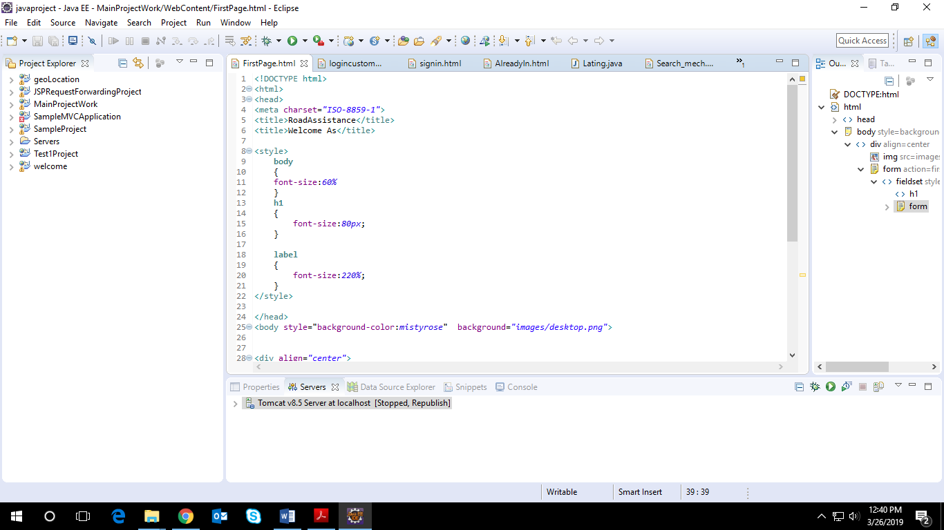

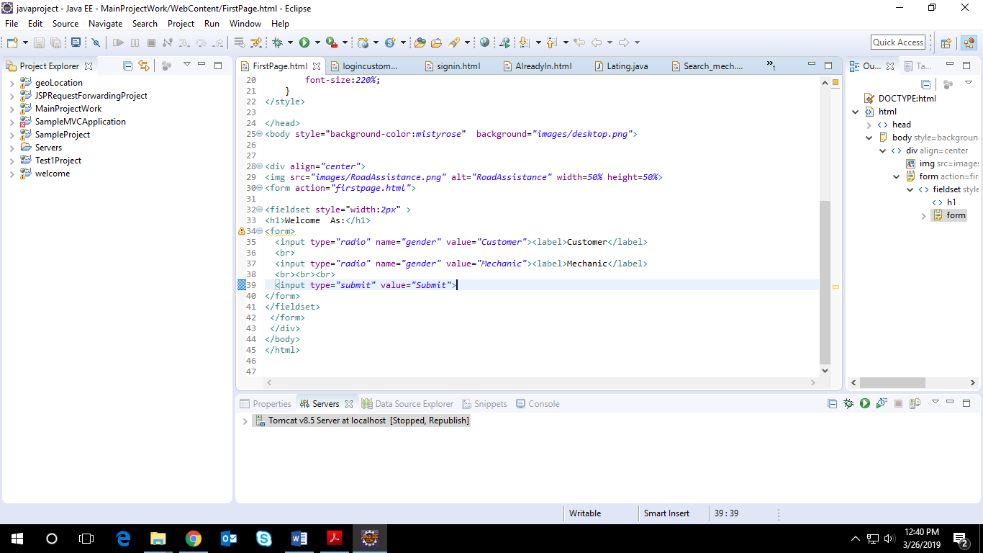

CODES REQUIRED FOR MIDDLEWARE

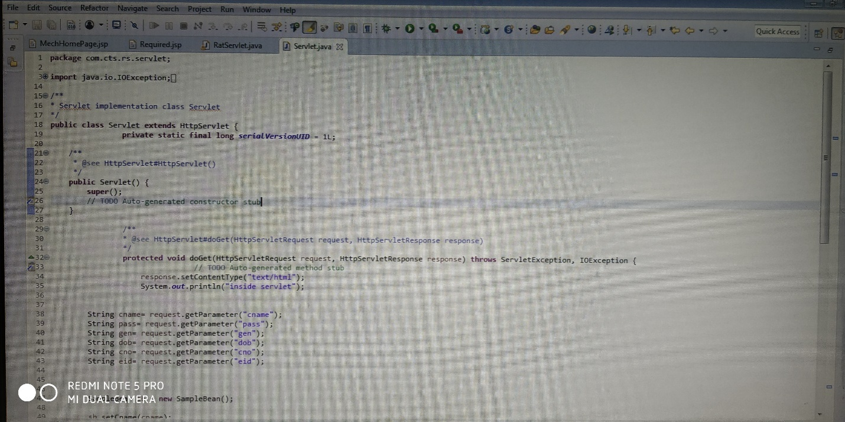

CODES FOR BACKEND

